Digital Voting System in Bangladesh using Biometric Cloud Computing Technology

Dept. of CSTE
Noakhali Science & Technology University
Sonapur, Noakhali-3814, Bangladesh
Email: syfulcste@gmail.com
Nazia Majadi
PhD Student/Researcher, School of ICT
Griffith University, Brisbane
Queensland, Australia
Email: nazia.majadi@griffithuni.edu.au

Abstract: In a democratic country like Bangladesh, public opinion is one of the most important determinants to establish a government and voting is the process through which people display their opinion and help to establish a democratic government. Now a days, Vote accuracy, security and confidence are crying need in any electoral process of Bangladesh. Also traditional paper based voting system in Bangladesh has witness a lot of challenges to accomplish a fair election process. So the Election Commission of Bangladesh (ECB) is searching for a way to modernize elections through electronic systems that will provide many advantages such as efficiency, a series of security requisites, disseminating results more quickly in a cost-effective way. Since the internet revolution and advances in information and communication technology (ICT) in Bangladesh have dramatically changed in term of cloud technology, so time has arrived to replace the paper based primordial voting system which has already proven itself an inefficient, costly and slow procedure. The main purpose of our strategy is to propose a highly secure digital voting system, incorporated with cloud based computing through biometrics that will help to perform not only a fair election but also create more authentication, transparency & security in voting system which may be an appealing step of digitizing Bangladesh.

Keywords: Biometric Cloud Technology; Biometric Recognition; Digital Voting; Election Commission of Bangladesh (ECB).

- INTRODUCTION
The increase of Internet penetration in the last years is boosting the popularity of Digital Voting System to setup a democratic government throughout the world. Like other countries, Bangladesh has been also faced with lot of challenges associated with traditional paper based voting systems prone to tampering and security infringements [1]. For solving this crisis, digital voting can be a promising technology that will ensure the possibility of a convenient, efficient and secure facility for recording and tallying votes. In our entire paper, we will try to represent an enhanced and secure voting system for Bangladesh using biometric data in co-operation of cloud to provide on demand services so Government may purchase or rent the infrastructure as required and install it in more cost effective way.

- LITERATURE REVIEW
For Bangladesh, one of the most densely populated countries
in the world, the creation of an accurate voter registration database has been a monumental task. In anticipation of national elections held in 2008, the government of Bangladesh launched a process to update the voter list. Prior to 2008, there was no formal identity card with photographs. This caused a huge possibility of fraudulent voting and there were allegations of a large number of fake voters in the electoral roll. During the tenure of the caretaker government, the Election Commission (EC) developed an electronic database of voters with photographs and their particulars. The Bangladesh Voter Registration Project registered more than 80 million voters using biometric face and fingerprint technology [2]. Recently, ECB has upgraded its biometric identification that stores voter information such as fingerprints, photos, signatures and contact details for approximately 89 million Bangladeshi voters. The voter identity card has taken the form of a National Identity Card (NID) issued by the Election Commission (with permission from the Ministry of Home Affairs) that can be used for voting as well as other purposes (e.g. opening bank accounts, applying for credit cards, etc[3]. In a sample of the NID, the front of the card has written in both English and Bengali. The logo of the Government of the People's Republic of Bangladesh and a watermark of the Shapla, the country's national symbol, photograph with signature of the NID holder are on the card. On the back of the card, there are spaces for the signature of the issuing authority, the card holder's blood type and the date of issue. A bar code is found near the bottom. Fig 1(a) and 1(b) shows a sample NID card.

 | 
Fig 1(a): Front view | Fig 1(b): Back view

- EXISTING VOTING SYSTEM

3.1. Paper-Based Voting
Department of computer science & telecommunication engineering
(sponsors)
The voting system that exists currently in Bangladesh is totally paper based and manual that takes lots of time and the government has to bear the heavy financial expenses for this purpose. This method requires the presence of the person himself to the voting place and time specified and that stands in the booth and vote to choose one of the candidates in confidence and then put the paper in the ballot box. Again the authority itself may be corrupted and can allow some fake voters to participate. Most importantly, the error that may happen during counting of votes. In addition, it requires high cost of processing and time expenditure . As well as, there are security problems which may affect the functioning of the electoral process.

3.2. Electronic voting machines (EVMs)

Electronic Voting Machine (EVM) is one of the leading products of Pi Labs Bangladesh Ltd for creating a new dimension in the electoral process of Bangladesh. EVM machine contains a memory chip and a removable memory card. When voters cast their ballot, votes are recorded to the chip and the removable memory card. In Bangladesh, EVM was first used partially in Chittagong City Corporation (ChCC) election in 2010 and then in Narayanganj City Corporation (NCC) election in 2011 with hopes of introducing it in the national election (likely to be held in 2014) [4]. But it also has some security problem in case memory damage or lost by polling officers.

- PROPOSED DIGITAL VOTING SYSTEM

4.1. Defining the Term-“Digital Voting”

Digital Voting technique refers to the use of information and communication technology(ICT) by governments to provide voting services to citizens, government employees, business and other agencies online through the internet to reflect their opinion in some important decision making, at local, national or international level. The advantages of digital voting are timeliness, responsiveness, and cost containment which are substantial. Digital voting allows for interactions with government without the limitations of time and space imposed by office hours and municipal buildings, resulting in reductions of operation inefficiencies, redundant spending, and excessive paperwork.

4.2. Basic Requirements of Secure Digital voting System

In order to be considered as secure, digital-Voting protocol must accomplish a set of basic requirements [5]:
-Privacy: votes must be kept secret. - Completeness: all the valid votes should be counted. - Soundness: non-valid votes should not account in the final result. - Unreusability: a voter can only vote one time. - Elegibility: only people with the right to vote should be able to vote. - Fairness: No external factors can affect the voting process. - Robustness: The voting should be carried out in spite of partial failures of the system.

- CLOUD COMPUTING IN DIGITAL VOTING

Cloud computing creates a new era of network technology. Biometric security such as Fingerprint scan, face recognition, geometry of hand, Iris scan and retinal scan are incorporated in cloud computing. Cloud user is authenticated by their fingerprint, face, retina, iris scan [6].

5.1 Biometric security involved with cloud computing

The National Institute of Standards and Technology (NIST) invented new protocol for cloud based services and WSBD (Web Services Biometric Devices) authentication using biometry in web service. Cloud service adopts standardized forms of communication which save cost and time both. Biometrics is essential in recent day mainly for big data and wider access of user. Large numbers of biometric data such as fingerprints, iris, and facial scan images which are needed for verification technology are too stored in large database. Some research report shows some challenges about biometrics as population are increased day by day and it may be inherently probabilistic. But when biometric features are integrated with cloud computing it effectively handle the challenges [7]. Biometric security services are as follows:

5.1.1 Cloud computing with Biometrics as a Service (Baas)

BaaS includes matcher, biometric capture, enrollment process for authentication with full biometrics capabilities. BaaS supports on demand process to reduce cost and enhance the elasticity feature of cloud also. It providers provide the support of scalability (management of large number of biometrics), multiple modalities (management of different types of biometrics), and matching performance. BaaS responsible for easiness of security of biometric data.

5.1.2 Identity as a Service (IDaaS)

IDaaS is also another service similar to BaaS but it provides more comprehensive delivery of Cloud-based identity management which includes biometric data. IDaaS supports scalability and reliability feature with on-demand facility.

5.1.3 Biometric authentication for the cloud

Security data access scheme related with identity-based encryption and biometric authentication for cloud [8]. Biometric feature based on following characteristics. Design considerations, arbitrary records and metadata, Common biometric matching API, Real-time, parallel and bulk processing, Flexibility, recovery, redundancy strategies communication [9].
5.2 Design of biometric Security infrastructure in cloud systems

Designing the biometric infrastructure in the Cloud, we first configure SaaS(Software as a service), PaaS( Platform as a Service) and IaaS(Infrastructure as a Service).The biometric cloud configuration should comprise a template biometric database and good network connectivity for conducting verification test in cloud [10].

5.2.1. Configuration of IaaS

Some hardware tools (pattern recognition tools authentication /verification device) need to be installed. Biometric operating system (Linux, windows) are the key component of biometric server. Biometric template database are stored in storage. Various transactions result (verification, identification) are stored in associated database and stored in to storage. Biometric cloud infrastructure should need a good connectivity to host provider and recognize identity of a person through biometric device.

5.2.2. Configuration of SaaS

SaaS components can be rented or purchased by consumer in on demand basis for customized development. The software platform provides the opportunity to user to develop their own biometric platform that are integrated with cloud infrastructure.

5.2.3. Configuration of PaaS

PaaS is the combination structure of IaaS and SaaS and work accordingly also. PaaS supports larger version biometric application in business scenario.

5.3 Virtualization related with biometric cloud computing

Different virtual servers, storage and network are major part of infrastructure of cloud Biometrics. Administrator of cloud service should need a total control in biometrics application. Each cloud data based biometrics application should contain their own unique Internet Protocol (IP) address so that they can be uniquely identified [11].

- PROPOSED VOTING SYSTEM USING BIOMETRIC EXTENSION OF CLOUD TECHNOLOGY

Fig. 2 depicts a general model architecture of our proposed system, for conducting efficient and credible elections in Bangladesh. The mechanism is designed to record votes by means of ballot display with LCD screen that can be activated by the voters, typically by push button or touch screen; processes vote’s data by means of a computer program and records them in central database. The system can be interlinked with a highly secured network that allows for quick and accurate voting electronically. It uses a client/server method which allows voters to cast ballots on the client terminal. Each client interfaces with the central server, which keeps track of the entire system. The process involves registration, verification, authentication, voting and tallying. The intended voter upon registration has a voter’s card with his or her bio-data, fingerprint and photograph printed on it to be used during accreditation and election on the Election Day. In the design, only the central authorized administrator has access to the central database/server. In the proposed system, voters can mark their votes directly into an electronic device, using a touch screen, push buttons or a similar device when voting. The voting terminals are connected via a dedicated network to the central machine, recording votes as they are cast.
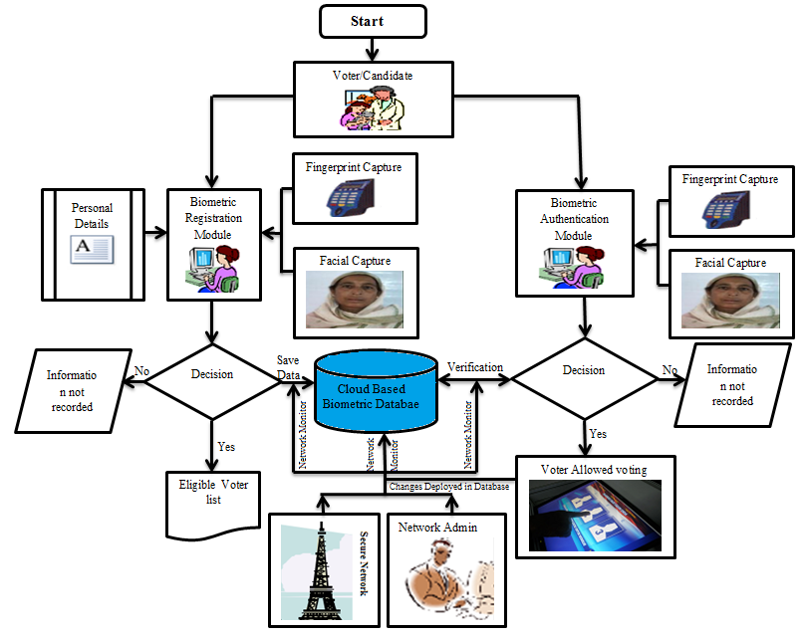
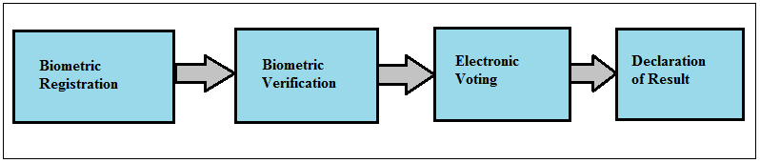Fig. 2: General diagram of Biometric (Digital) voting architecture

6.1. Biometric Registration of voters & Candidates

This involves the process of capturing an eligible (18 years of age or above, with a sound mind, a national and resident in the country) voter’s (Name, Date of Birth, Home town, Language, Address, Family, Passport. photograph, etc) and candidates(Name of Candidate, Party Name and Logo if applicable, portfolio or position vying) personal information including fingerprints using the fingerprint machine to scan the fingers and stored to the voters database that will be used for authentication or verification on election day. Fig. 3 describes the sequence diagram of voter/candidate registration process:
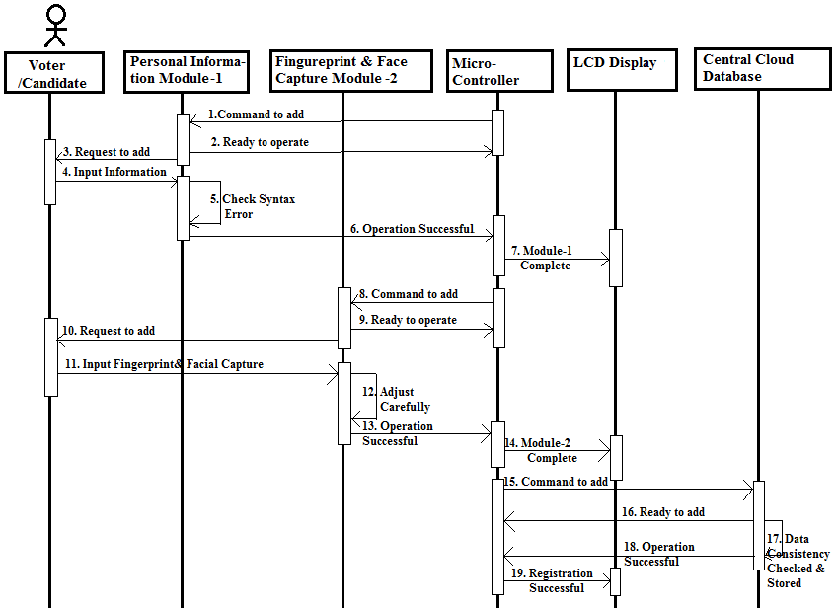
Fig. 3: Sequence diagram of voter & Candidate registration

6.2 Biometric Verification

A fingerprint and facial recognition system operates either in verification mode or in identification mode. The various stages in a fingerprint and facial verification system are shown in Fig. 4.
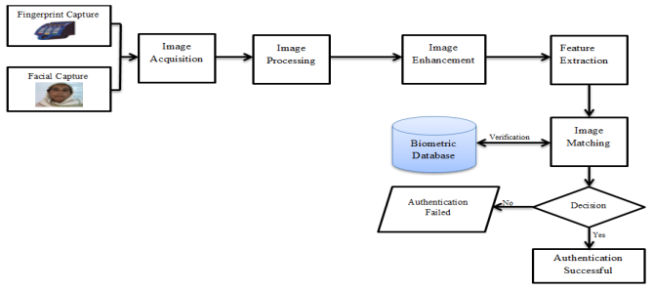
Fig. 4: Architecture of Biometric verification System

A. Fingerprint Recognition

Fingerprint recognition or fingerprint authentication refers to the automated method of verifying a match between two human fingerprints. A fingerprint looks at the patterns found on a fingertip. It is not surprising that the workstation access application area seems to be based almost exclusively on fingerprints, due to the relatively low cost, small size, and ease of integration of fingerprint authentication devices. Fingerprint verification may be a good choice for in e-voting systems, where the system operates in a controlled environment (see Fig. 5).
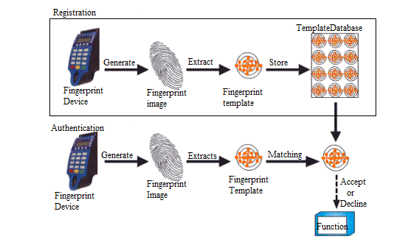
Fig. 5: Fingerprint Recognition module [12]

B. Facial recognition

Facial recognition systems have the same block diagram as any other biometric modality (see Fig. 6). After capturing an image of the eye, the iris is located and segmented to extract its features; these features are then compared to a previously stored template.
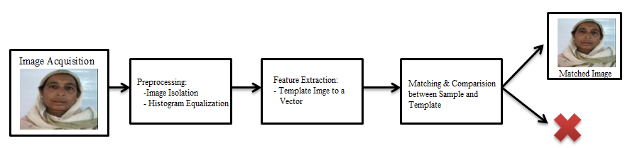
Fig. 6: Facial Biometric System

C. Feature Extraction

In the feature extraction block, begin with a normalization of the segmented iris image. This normalization becomes necessary when considering that the pupil varies in size for different light intensities. The normalization method varies from changes to the polar coordinate system, considering a virtual line drawn around the pupil, known as the iris signature. After normalization, phase the information is cleaned up by applying different Gabor filters. This is then followed by the codification of this information in terms of the quadrant where the phase belongs however, Wildes performs the extraction using Laplacian or Gaussian filters by obtaining several images of different scales for posterior comparison.
D. Template Generation: The Template Generation Module, based on Mega-Matcher Client, reads the WSQ images from the MySQL database and generates fused face and fingerprint templates that are then stored in a SQL Server Database. Mega-Matcher then uses these templates to carry out the biometric “N-to-N” matching process that identifies duplicates within the database records.

E. N-to-N Matching

Matching carries out fusion matching by providing two options: 1. Fuse always 2. Face then fuse. The first option, “Fuse always” is for a complete N-to-N matching strategy which requires much more time than that of second option. “Face then fuse” means that the system first generates face score, and if the score crosses the threshold value then the respective finger template is matched. Due to the high speed of the Mega-Matcher face matching algorithm, this process significantly reduces the amount of time required to identify duplicate entries ( see Fig. 7).

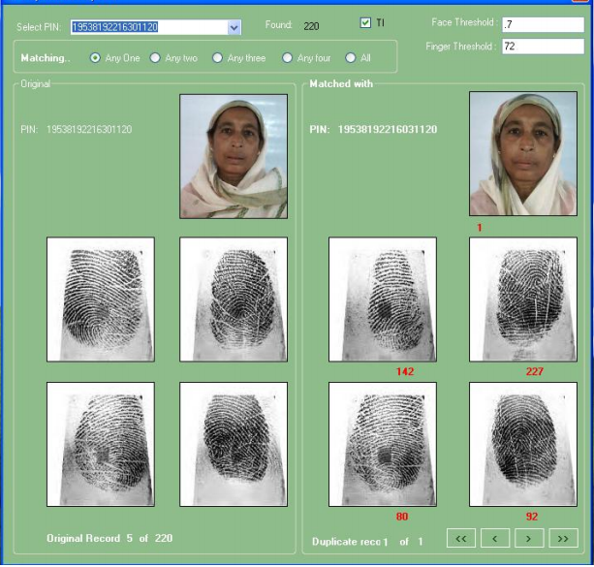
Fig 7: N-to-N matching

6.3 Digital Voting

In term of digital voting, when the voter enters the voting place, he/she must have same kind of valid identity, which has been stored in the database for Verification. Authorized person choose to online e-voting system. There are three conditions for valid identity Verification to allow polling section system that will be implemented is shown in Fig. 6. When a poll worker confirms that the voter is registered, means go to next state, answer to polling question ,this answer correct means go to next state finger print& face matched to database , matched means this person valid to next condition otherwise automatically closed voting screen site. The sequence diagram given below in Fig. 8 will further clarify the voting system:
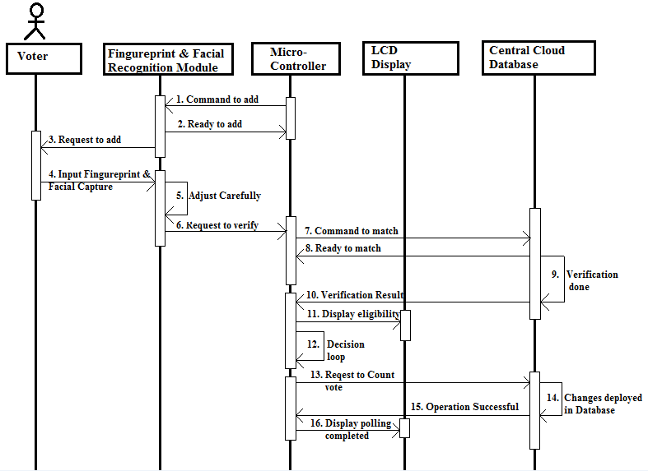
Fig. 8: Sequence diagram of digital voting process

6.4 Vote Counting and Collation of Results

While voting is in progress, the software would tally each candidate’s votes as and when an eligible voter selects the candidate by clicking or touching the passport size photograph, Name of the candidate or the logo if applicable. The percentage of vote cast by each candidate is calculated and their respective positions determined as soon as polls closes. The voting software will display the results after the elections by the electoral official as shown in Fig. 9.
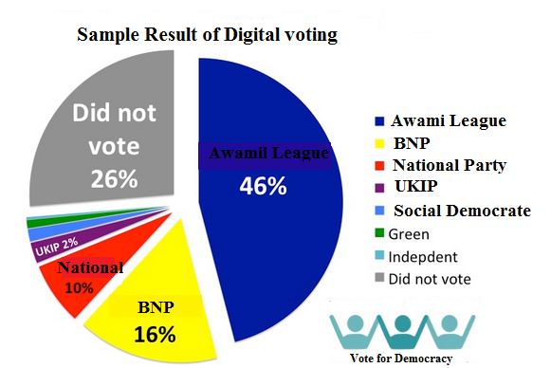
Fig. 9: Election Result

- PROSPECT OF DIGITAL VOTING SYSTEM

Digital voting has many strengths and opportunities for Bangladeshi nation. Some of them are:
- Democracy: It permits only eligible voters to vote and, it ensures to vote only once. The process of collecting votes is secure, reliable and accountable.
- Accuracy: The invalid vote cannot be counted. Therefore digital voting is uniform and confidential, so the national committee could successfully maintain the highest level of security.
- Privacy: The proposal will maintain the major principle of e-voting in secure & cost effective way. Neither authority nor anyone else can link any ballot to the voter.
- Robustness: Any number of parties or authorities cannot disrupt or influence the election and final result. To have confidence in the election results, robustness will be assured.
- Availability: The system will work properly as long as electricity is available and the devices are error free.
- Cost efficiency: The main objective of adopting cloud computing is to provide the voting service in a cost-effective convenient way, consuming the IT resources in reduced amount. Using cloud computing, IT costs such as infrastructure, maintenance and operational costs will be decreased. Thus, Election Commission of Bangladesh (ECB) can perform corruption free election with low capital.

- PREPARATION FOR ADOPTING DIGITAL VOTING

Willingness to change is the first of several important factors that should be considered. There are four major dimensions in order to develop a model of e-Voting system. These are: the political, legal, technological and social dimensions. But in the context of Bangladesh (according to present digital opportunities, political and other socioeconomic prospects) the following seven dimensions need to be considered for e-Voting readiness.
- Security: In public platforms of cloud computing due to adjacent physical data and users' environments, some threats such as information leakage, side channels, covert channels and etc. may occur. So ECB has to make strong agreements with cloud service provider to monitor these security issues.
- Confidentiality: Providers must have to ensure that all critical data should be mask or encrypted and so that only authorized users have access to data in its entirety. Moreover, digital identities and credentials must be protected as should any data that the provider collects or produces about customer activity in the cloud.
- Financial: Cloud computing changes IT budget from capital to operational. This change must be considered in the case of organizations budgeting process.
- Legal: With storing data in third country, Election Commission of Bangladesh (ECB) must be aware of legal issues in the field of international and national law of both source and destination countries.
- Learning: In cloud computing adoption by Election Commission of Bangladesh, consider staffs and IT managers' training is important.
- CONCLUSION

Voting is one of the most critical features in any democratic Process. That’s why; the voting processes should be fair, accurate and acceptable for all stakeholders. Electronic voting system is emerging as significant alternative to the conventional systems in the delivery of reliable and trusted elections. Biometric system denies the unauthenticated voter to access the system and prevent the same voter to cast multiple votes. Biometrics integrated with Cloud will be highly accepted in future because Infrastructure of biometrics can be configured very quickly and it is on demand basis and database will efficiently store the large database of e-voting system. In this paper, a framework for digital voting system based on biometric cloud computing is proposed and implemented with the objective of eliminating corruption in voting and vote repetition, less election expenditure, more transparency and fast results which may help Bangladeshi nations to be one step ahead in democratic election process in the globe .

REFERENCES

- Bangladesh Election Commission (BEC): bdallinfo.com/bangladesh-national-id-card [Last visited: 01/03/2015].
- Oracle-Press-release: https://www.oracle.com/bd/corporate/pressrelease/1-5416.html [Last visited: 07/03/2015].
- Bangladesh. N.d. Bangladesh Election Commission (EC). "National ID Card.", Available from: http://irbcisr.gc.ca/Eng/ResRec/RirRdi/Pages/index.aspx?doc=453071 [Last visited: 07/03/2015].
- M. Mesbahuddin, SARKER1, M Nazrul, ISLAM2, “Management Of Sustainable, Credible And Integrated Electronic Voting (E-Voting) System For Bangladesh”, Management of Sustainable Development Sibiu, Romania, Volume 5, No.1, June 2013
- Lee, B and Kim, K., “Receipt-free electronic voting scheme with a tamper resistant randomizer”, In Proceedings of the 5th international conference on Information security and cryptology (ICISC'02), pp. 389 - 406. http://dx.doi.org/10.1007/3-540-36552-4_27
- Chakraborti, Bratati, “E-Voting security system through Biometric Cloud Computing Integration with virtual server application”, European Journal of Academic Essays 2(1): 6-9, 2015 ,ISSN (online): 2183-1904 ,ISSN (print): 2183-3818 .
- Jernej Bule, Peter Peer, “Fingerprint Verification as a Service in KC CLASS”, Cloud class conference-2012, Avilable at: videolectures.net/site/normal_dl/tag=731494/classconference2012_bule_class_01.pdf.
- D.Pugazhenthi, B.SreeVidya," Multiple Biometric Security in Cloud Computing ", International Journal of Advanced Research in Computer Science and Software Engineering, Volume 3, Issue 4, April 2013.
- M. Ahmed, A. Sina Md. R. Chowdhury, M. Ahmed,, Md. M. Hasan," An Advanced Survey on Cloud Computing and State-of-the-art Research Issues", IJCSI International Journal of Computer Science Issues, Vol. 9, Issue 1, No 1, January 2012 .
- Business Week June 2010: businessweek.com, [Last visited: 23/03/2015].
- Assessing the Security Risks of Cloud Computing 2008 Gartner, Inc, [Last visited: 03/04/2015].
- Alaguvel.R1, Gnanavel.G 2,Jagadhambal.K 3 ,“ Biometrics using Electronic Voting System with Embedded Security ”, International Journal of Advanced Research in Computer Engineering & Technology (IJARCET) 2, Issue 3, March 2013,

